PRESS RELEASE

Fall exhibition 2012 Merano Arte September 29, 2012 to January 13, 2013

PERSPECTIVES OF THE FUTURE. MERANO 1945 – 1965

With more than 300 artworks, most of which are unpublished, the exhibition tells its visitors about the buoyant, varied, and ambitioned cultural scene in the town by the Passer river.
Life in the postwar years was many-facetted and exciting. Despite the politically charged situations, people hovered between normalization, awakening, and high-flown large-scale tourist projects.
Ezra Pound, Oswald Kofler, Gina Klaber-Thusek, Hans Ebensperger, Mary de Rachewiltz, Gino Severini, Peggy Guggenheim, Renato Guttuso, Anton Frühauf, Salvatore Quasimodo, Ernst Nepo, Luigi Serravalli, Antonio Manfredi, Karl Plattner and many others were and many others were the protagonists who gave the town a boost to international recognition. Innumerable exhibitions, music, movie, theatre, and literature events led to a pulsating cultural life and attracted visitors from all over the world.

Starting with a series of artist portraits, the Merano arte entrance and hall will lead us through the fifties in Merano: Who were the protagonists? What did they think about the local understanding of culture in the postwar years? How did they deal with their presence, and what were their visions for the future? Who signed the Merano Manifesto, and what were its demands? Which artists held exhibitions at the Wunderbar and the spa administration?
The second section of the exhibition is devoted to the local artists of those years. Their works seen by themselves as well as in comparison with the works of international international artists illuminate their understanding of art in the interplay of representational and non-representational painting or sculpture, photography, collages, assemblages, arts and crafts, as well as jewelry design.
The final section of the exhibition is about lifelong friendships between artists, for instance between Anton Frühauf and Oswald Kofler as well as Hansgeorg Hölzl.

With works by: Joseph Brunner, Domenico Cantatore, Ugo Claus, Fabrizio Clerici, Jean Cocteau, Maria Delago, Susanne Demmel-Brunner, Fortunato Depero, Hans Ebensperger, Anni Egösi, Karl Erhart, Peter Fellin, Emanuel Fohn, Anton Frühauf, Henry Gaudier-Breszka, Gianluigi Giovanola, Friedrich Gurschler, Anton Kienlechner, Gina Klaber-Thusek, Hansgeorg Hölzl, Oswald Kofler, Alois Kuperion, Franz Lenhart, Joseph Mahlknecht, Antonio Manfredi, Roberto Mattá, Mario Marcucci, Marino Marini, Oskar Müller, Ernst Nepo, Emilio Dall’Oglio, Robert Du Parc, Filippo De Pisis, Karl Plattner, Rina Riva, Robert Scherer, Gino Severini, Mario Sironi, Luis Stefan Stecher, Lilly Stingel Gutweniger, Orfeo Tamburi, Fiorenzo Tomea, Claudio Trevi, Willy Valier, Giuseppe Viviani, Umberto Volante, Remo Wolf, Fritz Wotruba

Curator: Markus Neuwirth, co-curator: Ursula Schnitzer

The catalogue does not only feature the more than 300 works exhibited, but also 32 contributions by renowned authors as well as 200 further illustrations on the individual topics:

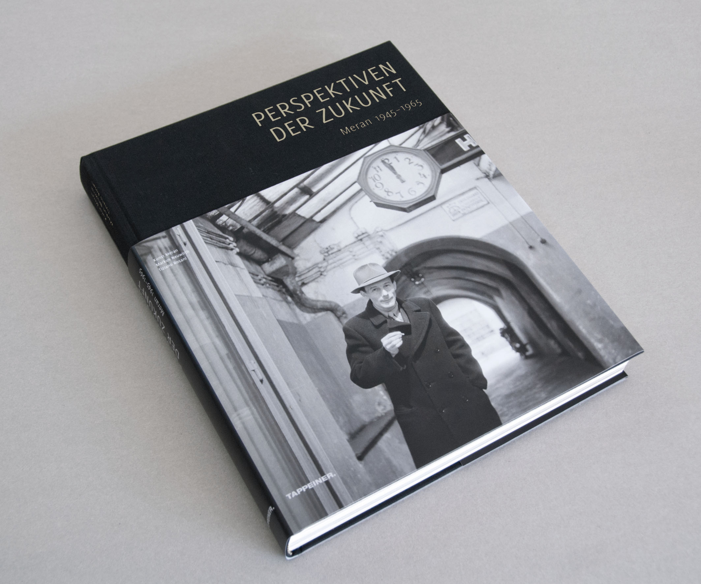

Hans Heiss: TEDIOUS NORMALIZATION IN SOUTH TYROL
Tiziano Rosani: OTHER PERSPECTIVES – THE MERANO TOWN ADMINISTRATION
Paul Rösch: THE SECOND SPRING OF AN OLD LADY – FRAGMENTS OF THE DEVELOPMENT OF TOURISM
Massimo Moser: BETWEEN INSECURITY AND DEVELOPMENT - THE INDUSTRY IN AND AROUND MERANO
Magdalene Schmidt: ARCHITECTURE AND CONSTRUCTION IN MERANO
Markus Neuwirth: FRUITFUL CONFLICTS
Giorgia Lazzaretto: EMILIO DALL’OGLIO
Nora Ranalter: HANS EBENSPERGER – REFLECTIONS OF HIS SOUL
Maria Grünbacher: PETER FELLIN – ENFANT TERRIBLE OF THE SOUTH TYROLEAN ART SCENE
Markus Neuwirth: ANTON FRÜHAUF – UNITY IN DIVERSITY
Barbara Unterthurner: OSWALD KOFLER – THE EYE OF THE MERANO PEOPLE

Rosanna Pruccoli: ANTONIO MANFREDI – POET, PAINTER, CRITIC
Irene Stauder: OSKAR MÜLLER – CERAMIST AND DESIGNER
Markus Neuwirth: JOSEPH BRUNNER – THE CULT OF MATERIALS AND THE ATTAINING OF FORM
Markus Neuwirth: HANSGEORG HÖLZL – TENSION AND CONTRAST
Karin Dalla Torre: GINA KLABER-THUSEK
Rosanna Pruccoli: UMBERTO VOLANTE – BETWEEN ART AND APPLIED ART
Rosanna Pruccoli & Tiziano Rosani: THE ART EXHIBITIONS AND THE ROLE OF THE TOURIST BUREAU 1957/58
Ursula Schnitzer: ARTIST, COLLECTOR, AND PATRON
Rosanna Pruccoli: LUIGI SERRAVALLI – A BOOK AND A MOVIE A DAY
Rosanna Pruccoli: BRUNNENBURG – LITERARY SALON AND THINK TANK
Ferruccio Delle Cave: BETWEEN GLOOM AND GLORY – THE LITERARY RECEPTION OF A TOWN
Carlo Romeo: EXPECTATION AND MELANCHOLIA IN A JANUS-FACED TOWN
Siegfried de Rachewiltz: EZRA POUND– THE MERANO YEARS
Leo Hillebrand: URANIA MERAN – NUCLEUS OF ADVANCED TRAINING
Georg Mühlberger: SÜDTIROLER KULTURINSTITUT AND DEUTSCHES THEATER
Roberto Cotteri: THE AKADEMIE DEUTSCH-ITALIENISCHER STUDIEN
Ewald Kontschieder: MUSICAL LIFE – THE MULTI-LANE MERANO POST-WAR MUSIC SCENE
Paolo Caneppele & Raoul Schmidt: THE TIME OF THE MERANO AMATEUR FILM FESTIVAL
Heinrich Schwazer: BETWEEN TRADITION, MODERNISM AND POLITICS
Paolo Bill Valente: THE CHURCH IN THE CHANGE OF TIMES
Leo Andergassen: THE CHURCH AS A COMMISSIONER

Editor: Merano Arte, Markus Neuwirth, Tiziano Rosani
400 pages, hard cover with dust jacket
Tappeiner Verlag 2012, ISBN 978-88-7073-709-7
Retail price: 49.90 €,

Fringe events and outreach programs for schools

In the Mood for Art?
Hannes Egger has invited the following guests to the Thursday evening events at Merano Arte:
Thursday, October 18, 2012, at 8 p.m.: Matthias Schönweger
Thursday, November 22, 2012, at 8 p.m.: Gunther Erhart
Thursday, December 13, 2012, at 8 p.m.: Francesco Palchetti
Admission fee and guided tour: 10.- €

Wednesday, October 3, at 8 p.m.
Language Games: Merano 1945–65 – The Sense of A New Era
Host: Paul Rösch; with Rosanna Pruccoli, Leopold Steurer, Paolo Valente; organization: Sonja Steger

Saturday, October 6
8th Day of Contemporary Art – AMACI
Free admission: from 10 a.m. to 10 p.m.
10:30 a.m. presentation of the work "The Glocal Rookie of the Year" by Armando Lulaj
11:00 a.m. presentation of the literary art calendar 2013 by Offizin S (in cooperation with Literatur Lana)

Friday, October 19
Special exhibition in the Sparkassen hall Psychiatric Landscapes
Opening: October 19, at 6 p. m.; exhibition period: October 19 - November 25, 2012
An exhibition by Südtiroler Landesarchiv in cooperation with Verein Geschichte und Region

Tuesday, October 23, at 8 p.m.
Get-Together at the Dopolavoro
Based on photographs, Florian Pichler and Wolfgang Ausserer will tell us about their meetings with artists from Merano at the "Dopolavoro" of the post office building in Merano.
Thursday November 29, at 8 p.m.
Musicians Who Witnessed the Years 1945-1965 Tell Their Stories
Host: Ewald Kontschieder
Tuesday, December 4, at 8 p.m.
Between Gloom and Glory
Literature in Merano 1945-1965: The literary reception of a town
Ferruccio Delle Cave

In the context of the exhibition "Perspectives of the Future. Merano 1945-65", Merano Arte offers
three outreach events as well as a dialog tour.
Host: Hannes Egger. Prior booking required!
Wonderful for elementary schools
At this event, the students will be asked to choose their favorite work of art. They will then ‘adopt’ and examine that work. This approach is suitable for children; without obstructing their view of the exhibition, it teaches them about the post-war years and the art movements of that time and encourages them to become active.

Merano Manifest for junior high schools
Around 1954, a number of creative artists in Merano published the "Meraner Manifest". The students will be guided through the exhibition, write their own manifest, and describe their cultural identity.

Point of View for high schools
This event is about the artists in Merano from 1945 to 1965 and is based on articles in the magazines Standpunkt, Alto Adige, and Dolomiten. The students will be encouraged to constructively explore the exhibition and work on the contents of the magazine articles.

Piccolo Bar for junior high schools and high schools
"Piccolo Bar" is a dialog tour of the exhibition. Merano artists used to get together at the Piccolo Bar. The tour will highlight the social importance of meeting at a bar and will present the exhibition and its cultural background through a vivid dialogue.

Kindly supported by:

the Department for German Culture of the Autonomous Province of Bolzano – South Tyrol

Ufficio cultura italiana della Provincia Autonoma di Bolzano – Alto Adige

Municipality of Merano – Department of Culture

Autonomous region of Trentino - South Tyrol

Stiftung Südtiroler Sparkasse

Südtiroler Sparkasse Etschwerke AG

State of Tirol

Universität Innsbruck

Merano Tourist Bureau

Athesia Verlagsanstalt

Staschitz Digital

Uwes Rahmenecke

Kellerei Nals Margreid

