PRESS RELEASE

EDUARD HABICHER – DRAWING SPACE

Curator: Valerio Dehò
March 6 – April 13, 2009

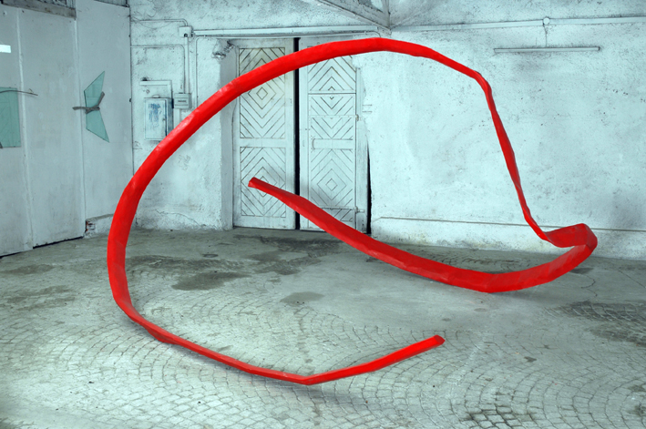
Eduard Habicher, Nucleo, 2005, sprayed steel, 285 x 420 x 500 cm, photo: Christian Martinelli

Parallel to the exhibition Contemporary Architecture in Finland (January 31–April 13, 200), Merano arte will open this year’s exhibition season with the works of two artists from Merano which hover between sculpture, architecture, and photography.
After the exhibition HOUSING, dedicated to the sculptor Ulrich Egger and also curated by Valerio Dehò, Merano Arte will present sculptures by Eduard Habicher from March 7 to April 13, 2009.

Habicher’s work is focused on the weighty metal he juxtaposes with space and renders ductile, almost light. By means of his interpretation of sculpture, Habicher renounces mass and defined volume for the sake of lightness. The energy of human labor and metal is paired with the concept of an essential and primitive language in which the bent matter is expressed through signs. The matter bends according to the artist’s will, fabricating arabesques and knots that move into the space freely, as if they were mental projections. But before the artist can turn to these forms, he must subject iron, sheet metal, and iron girders. They become something different, something new, a sign, waiting for written characters to collect and represent it.
Habicher positions his own artistic work in the field of ‘heavy’ sculpture that approaches ordinary building material beyond traditional materials. Habicher thus belongs to a genealogy of artists that is rooted in the ‘three-dimensional drawings’ by

Julio Gonzales and David Smith, free-moving sculptures that integrate into emptiness and space quite undramatically. Habicher endeavors to give the material the freedom it needs to take on essential and clear forms. Everything is aimed at emphasizing the artist’s ability to turn inanimate matter into expressive matter.
Virtual volumes, predefined by the sign language of the sculptures, develop in the emptiness or in relation to the architectural surroundings. At first, the viewer perceives the aesthetic quality of the works, which pushes the work process into the background. This process is only visible if one looks closely and analytically. The artist seeks a direct, almost personal dimension that appeals to the viewer and has nothing to do with monumentality. Habicher has adopted the entire sign language of 20th century sculpture and added his own characteristic sign to it, a clear sign that is different from other forms of poetics. The transformation and crossing of the material turns into an artistic alphabet, a language of its own that requires no additional levels of reference.
Color also plays a significant role in Habicher’s oeuvre. It is an expressive and effective part of his poetics and works, and it expands or shifts their meaning.
Habicher’s artistic quest is primarily about the clarity of an idea that defines the form within and is thus able to expand into its surroundings as a symbiotic and equivalent form itself. Habicher combines accuracy with particularly careful workmanship and an epic dimension. The result is a highly professional and intelligent kind of coincidentia oppositorum. And this, too, is contemporary sculpture: the ability to live with places, the analysis of space and architecture without neglecting the craftsmanship and hard work it requires. The simplicity of a poetics that manages to change forms by creating universally understood signs is still met with deep astonishment.

02

