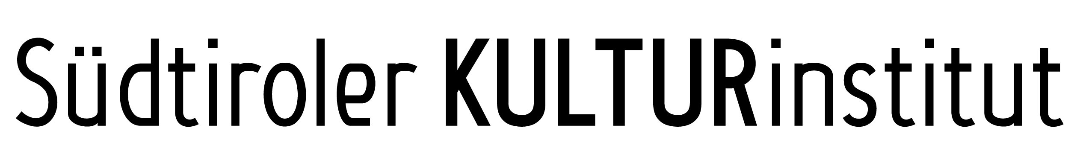

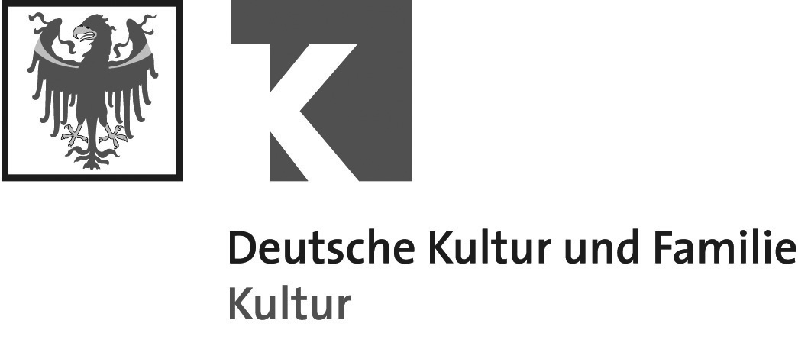

Desiring the Real. Austria Contemporary

Merano Arte June 22 – September 8, 2013
MUSEION June 22 – September 22, 2013

“The only thing a work of art can do is to stir the longing for a new world condition. And this longing is revolutionary.” Heiner Müller

The exhibition Desiring the Real was launched by the Austrian Federal Ministry of Education, Arts, and Culture, Department of International and Cultural Affairs. It presents works that have been purchased for the federal art collection over the past years, supplemented by works on loan.

Merano arte is presenting works by eleven artists from Austria who deal with various models of reality and whose work centers on the meaning of reality. The creative force of longing and desire is the mainspring of art, and reality is the material out of which art is made. The longing for reality is an artistic quest that attempts to fathom our existence by means of images, words, installations, and movies.

At first glance, Catrin Bolt's sculpture looks like a montage in a landscape, and that is exactly how it attempts to influence our perception of things. Her aim is to strip things of their purpose and thus to open their potential for new perspectives which otherwise would never have occurred to us without us having to take recourse to clichés. She began her series "Embracing Sculptures" with defense and war monuments in Carinthia, which had a rather militant look. Her intention was to change the scene completely through her personal presence.
Adriana Czernin plays with herself and with a shawl. Exaggerated ornaments are meant to elevate the importance of a woman, albeit for a brief moment.
Adapted to the background, women in earlier works seem always to have had the possibility to go beyond the constraints of the picture frame or to dissolve in the patterns of the tapestry, becoming one with the wallpaper.
Josef Dabernig. In the movie "Hotel Roccalba", "Living Pythagoras" creates shots on a grid of vertical and horizontal lines. 12 persons whose relationships remain unclear pass questions on to the audience.
Michael Goldgruber's works, be they photographs, paintings, or video and
sound installations, deal with tourist's perception of landscapes and nature. His motifs are observation decks made out of concrete, glass, and steel, which are enormous interventions in the landscape, but enable breathtaking views of untouched nature.
Maria Hahnenkamp explores our society, roles, and identity. The influence of the media, the exclusion of politics, religion, and culture, as well as the temptation of power are her main topics.
Siggi Hofer does not only seek the most beautiful watercolor painting and its longing for harmony, which ultimately leaves us unfulfilled. His collages also take over their messages: a photograph as a reflection, a painting as an artefact, writing as a literary element. Through the date, he sets a real point in time. Reality and fiction alternate.
Ulrike Königshofer is interested in history and the reproduction of the past. In her installation, she uses an image that shows the same person as a fifteen-year-old teenager and as a mature woman. Her pictures are projected one on top of the other, so the differences fade. And the question is, why do we always regard ourselves as the same person, seeing that our cells are completely renewed every fifteen years.
Bele Marx and Gilles Mussard take pictures of everyday objects, for instance wire coat hangers. The coat hangers are presented as a mass phenomenon, a confusion of light. An undefined web in which the individual elements can no longer be discerned.
From each point of view, the chaos of lines looks different. Sometimes
one's eye gets caught in the chagrin of crossing and overlapping wires;
sometimes one manages to recognize the other end of a hanger.
Margherita Spiluttini captures landscapes in the form of architecture. In her series "Nach der Natur", she photographs the way man deals with nature. Landscapes become designed territories, new spaces evolve, nothing is lost through man's intervention. Especially interventions in Alpine landscapes, which are generally considered the epitome of natural beauty, elucidate the interlocking of nature and technology.
Esther Stocker holds that reduction is a form of freedom in abstraction: not everything has to be pondered on. She equates the surface of a body with a canvas. If our eye cannot encounter the surface, we do not sense the space properly.
The artist Hannes Zebedin deals with political issues and processes them in the form of videos with unusual perspectives. A dog following its owner, the flag bearer at a political demonstration. The dog follows its owner, not knowing that that makes him a hanger-on. And how about us humans? Zebedin is deeply interested in political questions. His art focuses on the question to which extent political and social actions and systems can be used as the 'raw material' or 'condition' of making art.

In the context of Desiring the Real, Museion Bolzano will present two unpublished works by Judith Fegerl and Leopold Kessler in its Project Room.

On June 20 at 7.30 p. m, there will be an artist talk at Museion, with Josef Dabernig, in the context of the exhibition "Little Movements - Self Practices in Contemporary Art". Immediately afterwards, Judith Fegerl will introduce the works in the Project Room, and at 10 p. m., there will be a media facade projection by Rainer Gamsjäger. The projection by Rainer Gamsjäger will be repeated on June 21 at 10 p. m. The exhibition also includes a performance by the dancer and choreographer Sebastian Prantl, which is part of the program of the festival Bolzano Danza (in cooperation with Südtiroler Kulturinstitut, July 23, 6 p. m.).

Dr. Claudia Schmied, Minister for Education, Art, and Culture: Art is a tool and a medium to get people together. Introducing young Austrian art is one of the major aims of my cultural policy. In this context, my most important goal is to give young Austrian artists a global position and firmly network them with others all over the world. The presentation of the exhibition ‘Desiring the Real’ is one way to reach this goal: the exhibition will change, it will communicate, it will be a gateway and an entrance to today’s reality.

Dr. Sabina Kasslatter Mur, member of the South Tyrolean government, in charge of education and culture: The exhibition "Desiring the Real" is about contemporary art in Austria, and it is the result of several decades of cooperation between the Ministry for Education, Art, and Culture in Vienna and the Province of South Tyrol. We have close ties to Austria, especially with regard to culture. I am pleased that this exhibition offers visitors the opportunity to get a glimpse of contemporary fine art in Austria.

Merano arte, participating artists: Catrin Bolt (Friesach, 1979), Adriana Czernin (Sofia, 1969), Josef Dabernig (Kötschach-Mauthen, 1956), Michael Goldgruber (Leoben, 1975), Maria Hahnenkamp (Eisenstadt, 1959), Siggi Hofer (Bruneck, 1970), Ulrike Königshofer (Koglhof, 1981), Bele Marx & Gilles Mussard (Salzburg, 1968, Paris, 1956), Margherita Spiluttini (Schwarzach, 1947), Esther Stocker (Schlanders, 1974), Hannes Zebedin (Lienz, 1976).

Museion, participating artists: Judith Fegerl (Vienna, 1977), Rainer Gamsjäger (Bad Ischl, 1974), Leopold Kessler (Munich, 1976).

Curator: Karin Zimmer

Desiring the Real has been touring through various countries since April 2012. The first stations were MOCAB Museum of Contemporary Art Belgrade, Serbia, MUAC Contemporary Art University Museum Mexico City, FIC Cervantino International Festival, University of Guanajuato, Mexico, Centro de Arte Contemporáneo Wifredo Lam in Havanna, Cuba, GAALS in Culiacan, Mexico, and Museum of Contemporary Art in Zagreb, Croatia.

On June 21, 2013 at 6 p. m., the exhibition Desiring the Real will be opened at Merano arte. The opening reception will be attended by Minister Dr. Claudia Schmied and Dr. Sabina Kasslatter Mur, cultural member of the provincial government.

Afterwards, the exhibition will move on to: Macedonia, Turkey, France, Bosnia-Herzegovina, Russia, Latvia

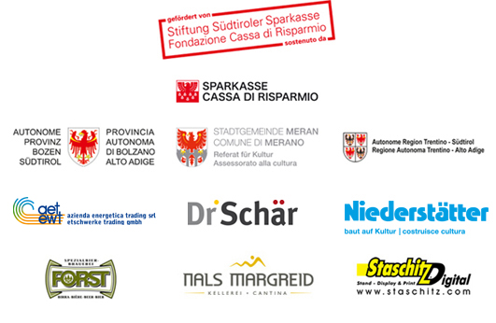Kindly supported by:

Desiring the Real. Austria Contemporary

A cooperation project by the Austrian Federal Ministry for Education, Art, and Culture, Merano arte, Südtiroler Kulturinstitut, and Museion - Museum of modern and contemporary art in Bolzano.
Curator: Karin Zimmer
Press conference: Friday, June 21, at 10 a.m. at Museion – Bolzano
Opening reception: Friday, June 21, 6 p. m. at Merano arte - Merano
Exhibition period: June 22 - September 8, 2013 at Merano arte
June 22 - September 22, 2013 At MUSEION

Contact Merano Arte Public Relations Department
Ursula Schnitzer
schnitzer@kunstmeranoarte.org phone +39 0473 212643

Contact Museion Public Relations Department
Caterina Longo -
caterina.longo@museion.it phone +39 0471 223428

Parallel to the exhibition "Desiring the Real", Merano arte will present:
Murano><Merano - Glass and Contemporary Art
Curators: Adriano Berengo and Valerio Dehò
With works by: Aldo Mondino, Antonio Riello, Aron Demetz, Bernardì Roig, Francesco Gennari, Fred Wilson, Jan Fabre, Jaume Plensa, Javier Perez, Koen Vanmechelen, Maria Roosen, Marya Kazoun, Michael Joo, Monica Bonvicini, Nabil Nahas, Oleg Kulik, Orlan, Pieke Bergmans, Pino Castagna, Robert Pan, Sergio Bovenga, Thomas Schutte, Ursula Von Rydingsvard, Vik Muniz.

