PRESS RELEASE

Alps
Architecture
Tourism
demonstrated by the example of South Tyrol

Opening reception: May 29, 2014, at 7 p. m.
Exhibition period: May 30 – September 7, 2014

Curator: Susanne Waiz

Alpine Architecture, Architecture for Tourism, or Architectural Tourism in the Alps: the title suggests three variant forms. At any rate, it is about architecture. Architecture is the essence of a building, its nature that remains largely unchanged over the decades. That is the basis of the longevity of high-quality hotel architecture. Furniture wears off or is lost, but walls last. Good architecture from around 1900 is still held in high esteem today, and we may assume that today's good architecture will still be valued in a hundred years from now. Whoever thinks of the future and of future generations, will immediately think of the architecture of his hotel.

The exhibition presents architecture for tourism - from a simple boarding house to an elegant hotel, from a cable railway station to the architectural sculptures on the Timmelsjoch. Architecture for tourism does not only involve hotels, but also those buildings that are referred to as "tourism landscape" in the exhibition. No other economic sector intervenes in the landscape as much as tourism does, with beneficial, but also alarming consequences. In many places, the preservation of the delicate alpine landscape is at stake, but on the other hand, many a high-lying hamlet would no longer exist if it weren't for the tourism industry.

The projects presented in the exhibition were selected from an architectural viewpoint. The focus is on the design quality of the buildings and their reference to the landscape and the surrounding architecture, whereas the common quality standards of the tourism industry were ignored. New tourism businesses were chosen alongside ones located in historical buildings. With regard to the latter, it was important to see how they have been adapted to the requirements of modern tourism, even if that meant only minimal interventions. Ruins of hotel architecture, such as Gio Ponti's Hotel Paradiso, were deliberately left out.

High-quality architecture can only last if it is supported by the builder-owners. Their ideas and visions were fathomed through numerous interviews. With this in mind, the exhibition is not primarily aimed at designers and architects; rather, it is meant to inspire innkeepers and all the other actors in the tourism industry. The tourists themselves are also welcome: after all, it is their expectations that are reflected by architecture for tourism.

In the context of the exhibition, Merano arte will become a meeting point for hoteliers and architects this summer. Three times a week, there will be architecture-tourism dialogs.
Innkeepers will meet architectures to discuss contemporary architecture in the tourism industry, their plans, and their questions.
36 successful architects from South Tyrol will take part in the dialog. During each of these dialogs, two architects will consult persons from the tourism industry. Participtation is free of charge – Prior booking is required (architektur@kunstmeranoarte.org; phone 0473 212643)

To accompany the exhibition, there will be a magazine that will be sent to all hotels in the province. In addition to various technical contributions and interesting interviews with hotel owners, the magazine will summarize the architecture examples shown at the exhibition: a convenient little guide to architecture for tourism.

Data overview

Title:
Alps
Architecture
Tourism
demonstrated by the example of South Tyrol

Curator:
Susanne Waiz, Bolzano

Exhibition period:
May 30 to September 7

Opening reception:
May 29 at 7 p.m.

Exhibition in three sections:
- historical hotels
- modern hotels
- infrastructure for tourism

Number of projects:
23 projects in towns and various valleys of South Tyrol

Forms of representation:
- photos, drawings, and texts on large screens
- models and individual pieces of furniture
- nine audio stations with interviews with hoteliers
- three-dimensional installation "Paradiso" by Elisabeth Hölzl
- installation "Brennende Lieb’" by Susanne Waiz in cooperation with freilich Landschaftsarchitekten on the terrace

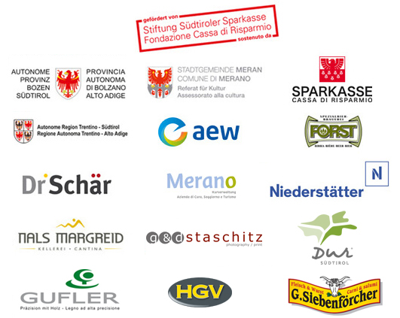
Kindly supported by:

