PRESS RELEASE

15.05. - 12.09.10

Pan-Alpine Architectural Traveling Exhibition Alpine Living Space—Contemporary Forms of Housing, Developments, and Perspectives of Alpine Living Space

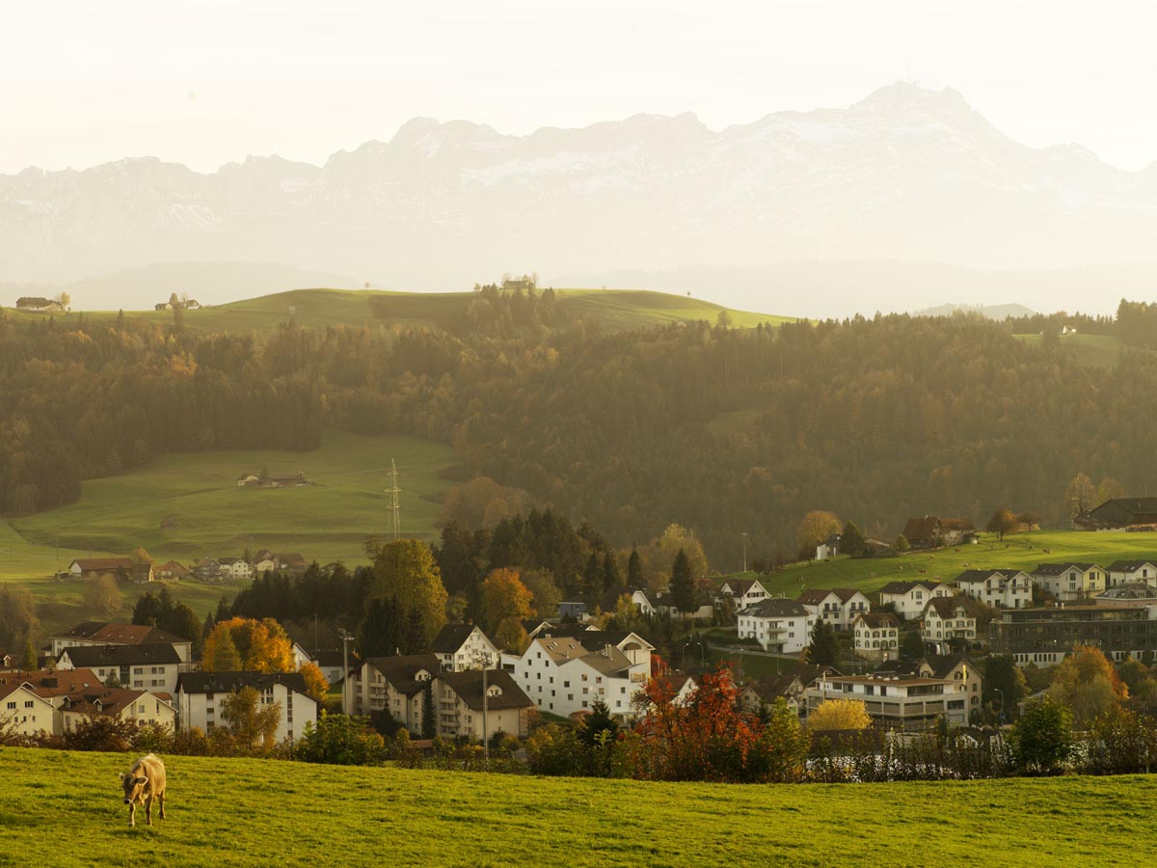

Teufen / Appenzell Region

The public interest in Europe’s highest mountain range remains undiminished. Perhaps city dwellers have a romantic idea of farming work against the backdrop of an idyllic mountain scenery, or it might be the non-stop après-ski party in the winter sports locations that keeps the myth of the Alps alive. But what happens behind the scenes of this starry-eyed notion of an Alpine ‘identity’ with authentic customs and traditional rites, nature boys, and the patron saints of Alpine landscapes? Surely, not every Alpine resident lives in ‘Heidi Land’ and works as a skiing instructor. What about the other 14 million people who live in the Alps? How do they live, and how do they perceive their living quarters and landscapes? This question is at the core of the exhibition initiated by Merano arte and the Stiftung der Kammer der Architekten der Provinz Bozen [Foundation of the Chamber of Architects in the Province of Bolzano] that will open in April 2010.

When it comes to living space, every visitor is an expert, a recipient, and a communicator at the same time. The exhibition, however, is not focused on spectacular single-family houses or vacation apartments in tourist destinations, but on various sustainable settlement developments—from multi-family houses to settlement structures—in the context of the Alpine region with its state-specific approaches and its references to the Alpine surrounding.

For the organizers of the exhibition, it was important to capture a wide range of residential forms, from girls’ boarding schools to senior citizens’ residences, and from subsidized houses for asylum seekers to spectacular secondary homes with a view of the mountains. The question was not how one should live in the Alpine region, but which residential buildings have actually been built in the Alps over the last ten years, and how do people live in them? The exhibited projects are a cross-section of the living space in this region, with special emphasis on various topics and problems. The reconstruction of the destroyed mountain village Gondo, for instance, shows how people have dealt with the given circumstances, the extreme topographic location, and the very scarce settlement area available. Other points of focus lie in the demographic development of society, from comfortable vacations that last until the end of one’s days down to supportive housing for patients who suffer from dementia, so their residence becomes part of their therapy. On the one hand, luxurious second homes mushroom in natural romantic surroundings, and on the other hand, there are low-budget buildings for migrants who are given the chance to gain a foothold in a new country. All this is captured and shown.
It took several months of research to select the projects. More than 200 projects throughout the Alpine region were found that meet the prescribed criteria (at least five living units, completed after the year 2000). From them, a body of 16 experts from the fields of architecture and landscape selected the 37 projects presented here. The result is by no means complete, but an open-ended snapshot of the current situation.

And that is how the exhibition shall be experienced: as a renunciation of deserted, vacant architecture with unintelligible explanations and a revival of buildings by their inhabitants.

For the documentation, the photographer Hartmut Nägele was commissioned, because he illustrates living spaces in a narrative, rather subjective way, like no other, enabling the viewer to enter into the world of his photographs for a brief moment. The image of a height profile with temperature curves has always been associated with the Alpine region; it forms the pivot of the exhibition structure.
Traditional patterns are broken, because the contributions are not arranged according to states, but heights. The exhibited projects travel across landscapes, settlement areas, and the Alpine region as a conglomerate. That makes the exhibition a unique experience for visitors and might give them a chance to get to know the intricate and culturally diverse Alpine region in the framework of an exciting discourse concerning the differences between the styles of living in the various Alpine states, beyond the view of a tourist. With all this, the words of Loredana Ponticelli in her essay Wehlsch Pirg are given overriding importance: “Only those who live in the Alps know what that truly means.”

Exhibition: 15.05. - 12.09.2010
Opening: Friday, May 14, 2010

Team of curators: Eva Herrmann, Markus Kuntscher, Peter Ebner, Munich
Team of architects: Georg Klotzner, Markus Scherer, Angelika Margesin, Luigi Scolari

Catalogue: The exhibition will be accompanied by an extensive publication, including essays by Miha Dešman, Köbi Gantenbein, Hansjörg Hilti, Wojciech Czaja, Loredana Ponticelli, Christian Schittich, and Axel Sowa, as well as a profound introduction to the particularities of South Tyrol, published by Birkhäuser Verlag.

